**Gemetric camera calibration:**

The problem of Estimating Intrinsic parameters and Extrinsic parameters of a camera ,process known as Gemetric camera calibration.

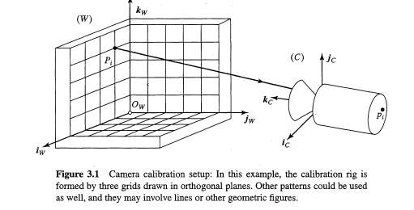

Least squares technique aimed at solving optimization problems before presenting **linear** and **non linear** approaches to calibration.

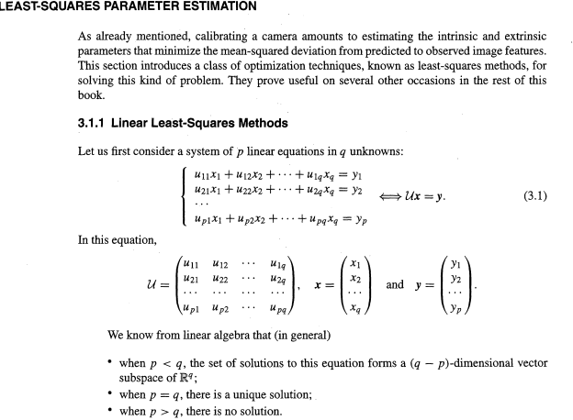

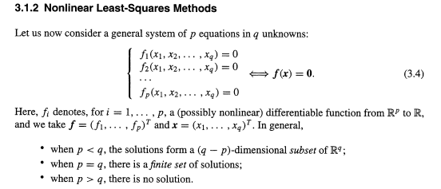

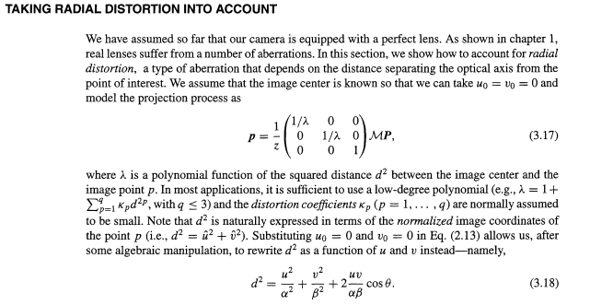

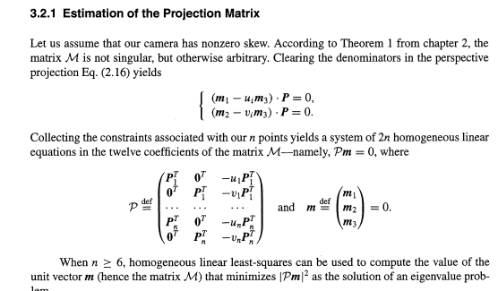

**Analytical Photogrammetry**

